HYCU Disaster Recovery Scenario for Amazon cloud
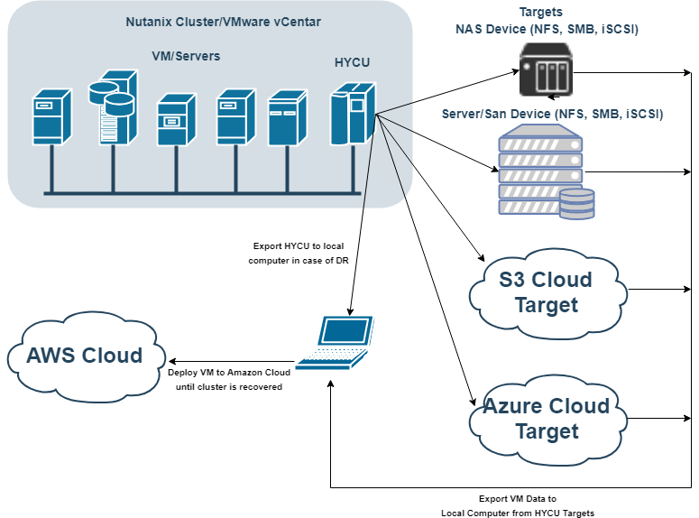

Prerequisites:
- Working Windows Physical Machine
- VMware Workstation player available for download on https://www.vmware.com/products/workstation-player/workstation-player-evaluation.html
- Installed and configured QEMU package for converting disk image files, Download QEMU From https://www.qemu.org/
- Backup of the HYCU backup controller (exported disk image files)
NOTE: use CTRL+ left mouse click on video links to open video
IMPORTANT: Watch for uppercase and lowercase letters in command

Contents
PREREQUISITE STEP 1 - Install QEMU tool 4
PREREQUISITE STEP 2 - Retrieve HYCU VM disk image files from backup target 6
STEP 1 – Recreate HYCU VM from its backup, using VMware Player 9
STEP 2 - Use HYCU to recover production virtual machines disk image files 16
STEP 3 - Install Azure PowerShell module and convert restored disk image(s) to vhd format 18
STEP 4 - Configure Azure for deployment 19
STEP 5 - Upload image to Azure and convert it to Azure Rm image 23
STEP 6 - Deploy the image into Azure and run the VM 25

PREREQUISITE STEP 1 - Install QEMU tool
  - video file
- Get QEMU from https://www.qemu.org/
- Install QEMU to local computer
- Add QEMU Install folder to Path Environment Variable
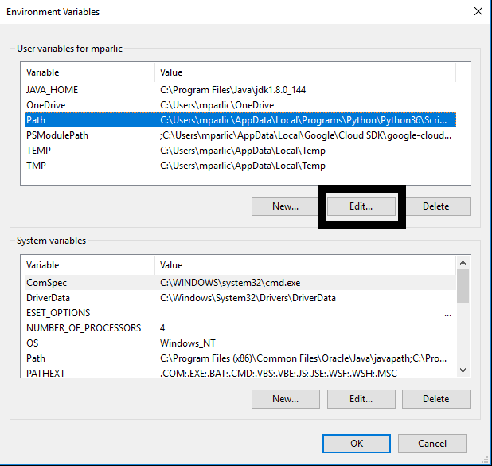
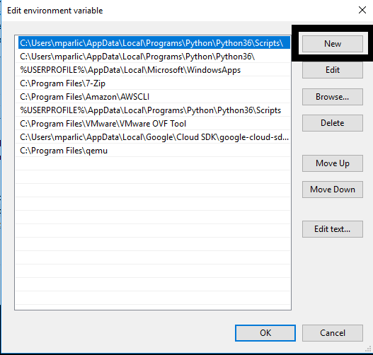
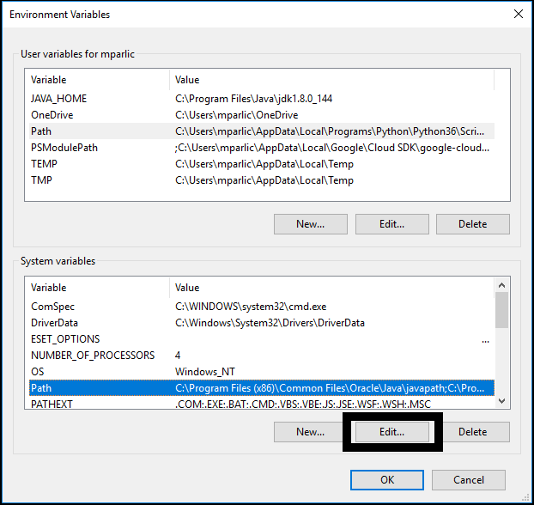
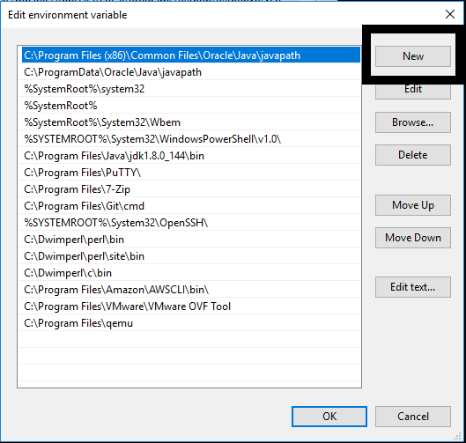

PREREQUISITE STEP 2 - Retrieve HYCU VM disk image files from backup target
  - video file
- Navigate to the target where backup of your HYCU backup controller is kept
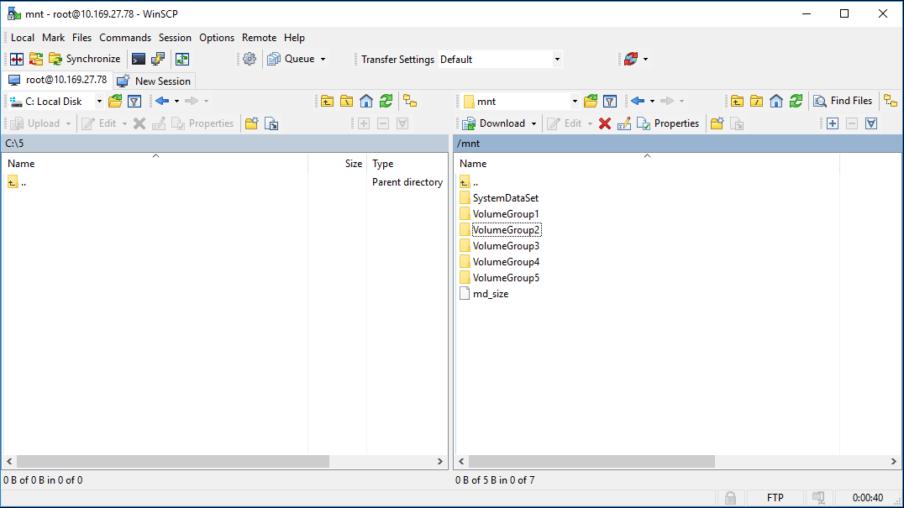
- Navigate to bkpctrl directory
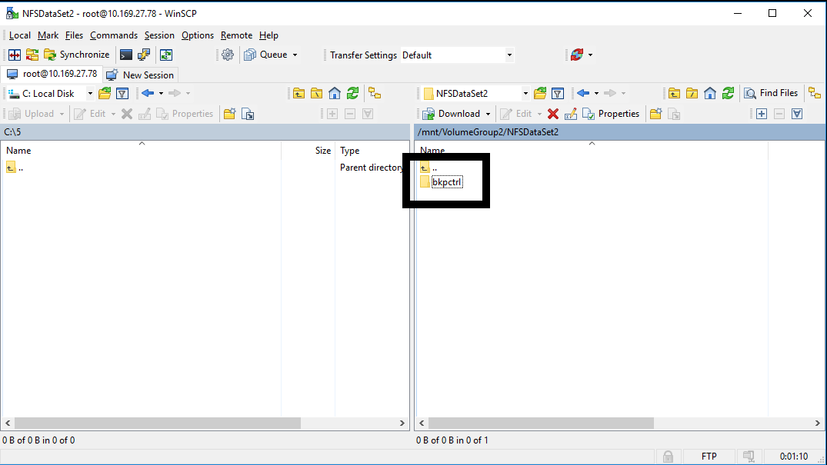
- Navigate to the HYCU uuid directory
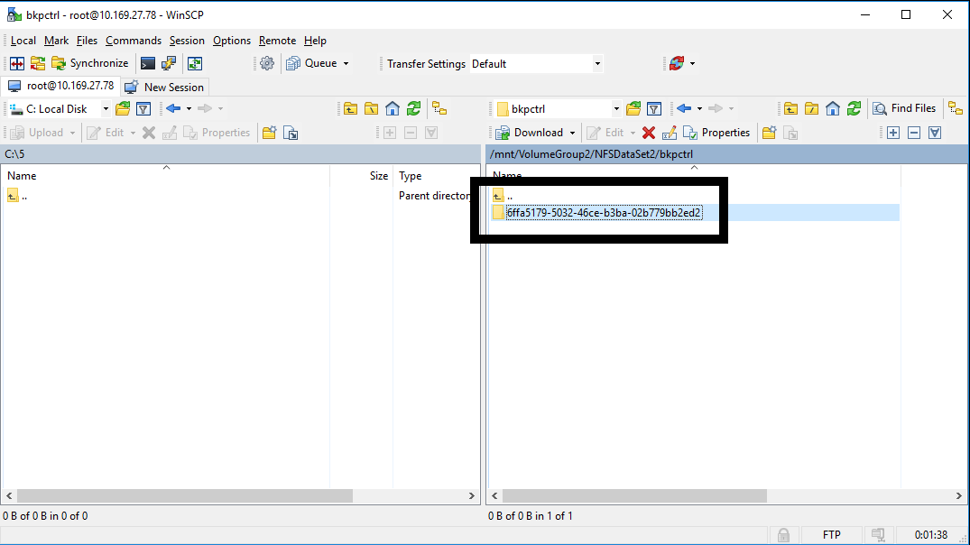

- Navigate to the directory internal_backup_<source UUID>
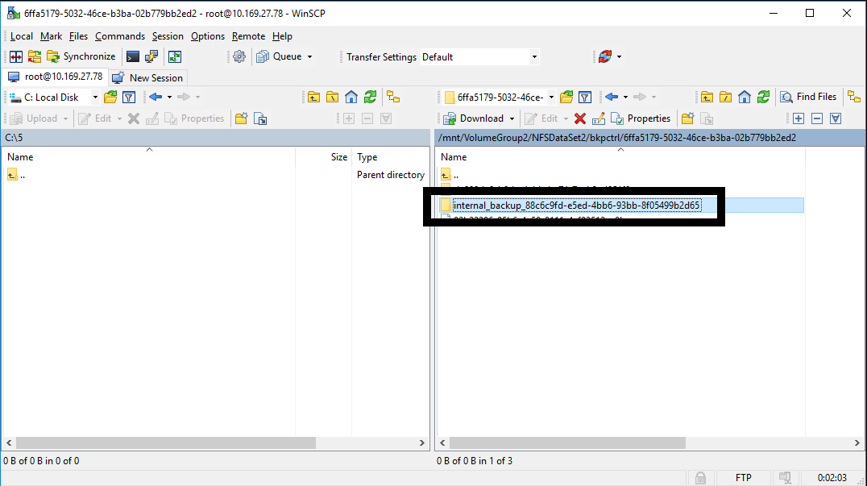
- Copy only the AHV raw disk image files (no extension) of HYCU backup controller disks to your local computer
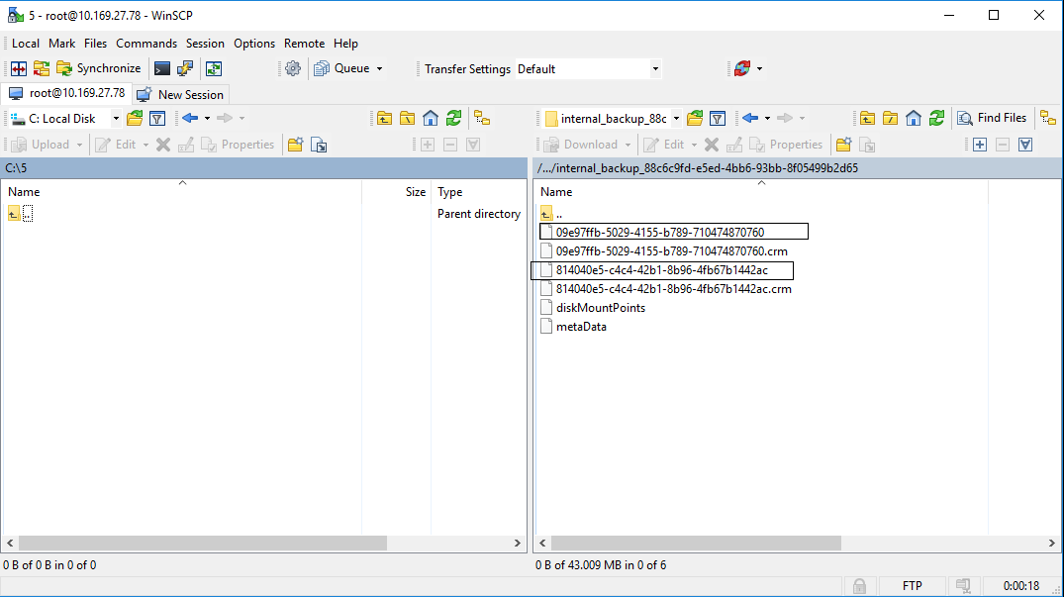
- Convert raw AHV disk image files to VMDK using QEMU tool
  - Smaller file (by default 10GB) is the HYCU system boot disk, the other one is HYCU data disk
  - Use the following commands
qemu-img convert -f raw -O vmdk <system disk image file> boot.vmdk
qemu-img convert -f raw -O vmdk <data disk image file> data.vmdk

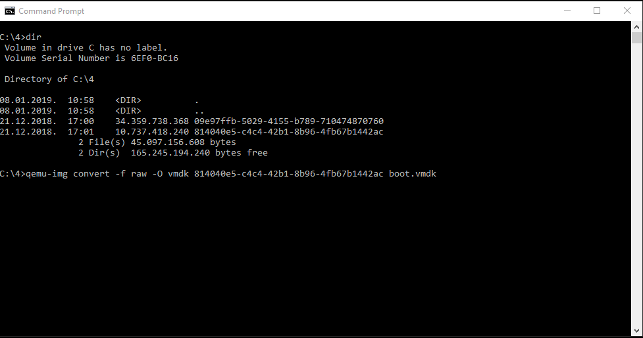
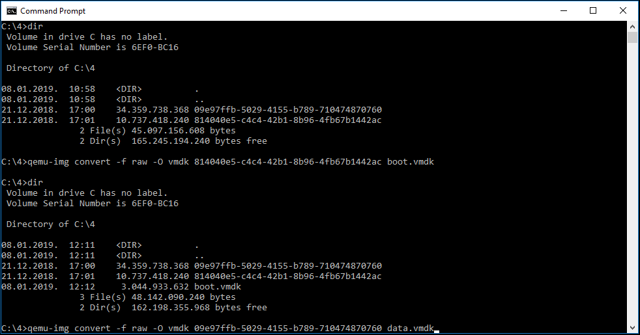

STEP 1 – Recreate HYCU VM from its backup, using VMware Player
  - video file
- Select Create New Virtual Machine
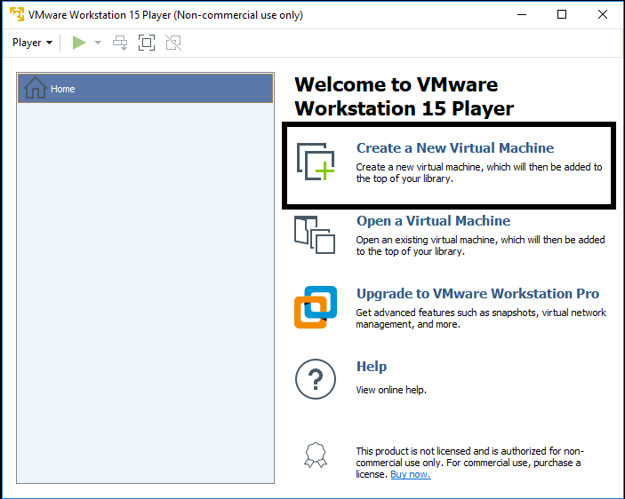
- On the next screen select “I will install operating system later”
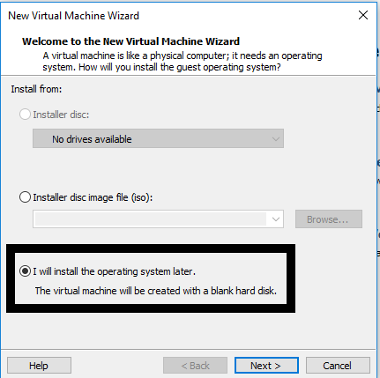
- On the next screen select Linux on top and Version CentOS 7 64-bit
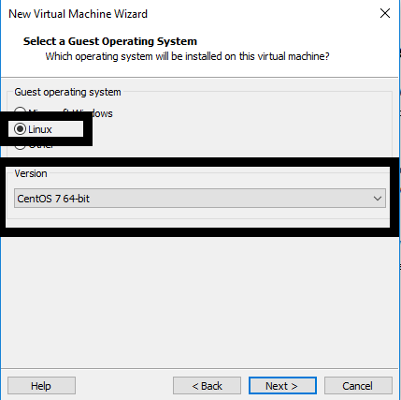

- Enter the VM name and select location on local computer where VM will be stored
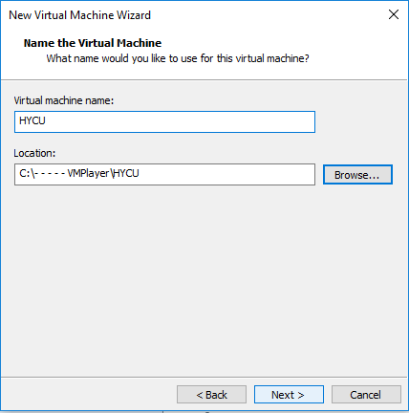
- Enter the size of VM boot disk (by default this is 10 GB) and select “Store Virtual disk as a single file”
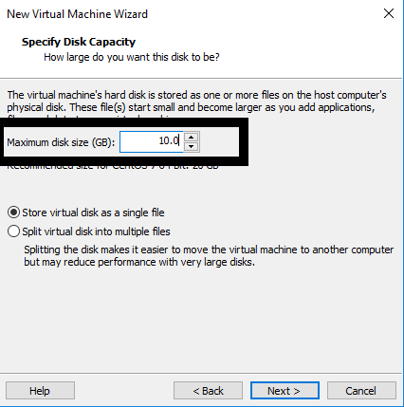
- Review VM details and click on Finish
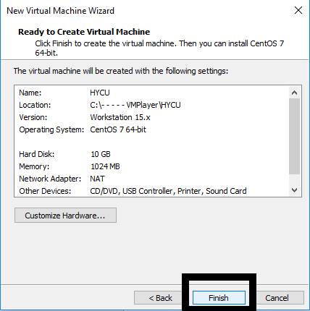

- Copy HYCU boot and data converted vmdk disk image files to the folder where your new VM was created
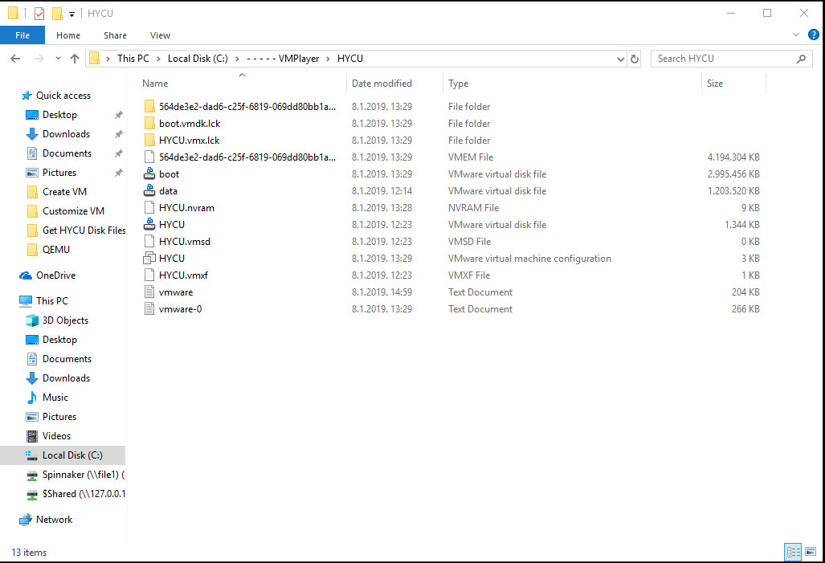
- Edit the .vmx file with a text editor. .vmx file is located in the folder where you created the new VM (change line scsi0:0.fileName = "HYCU.vmdk" to scsi0:0.fileName = "boot.vmdk")
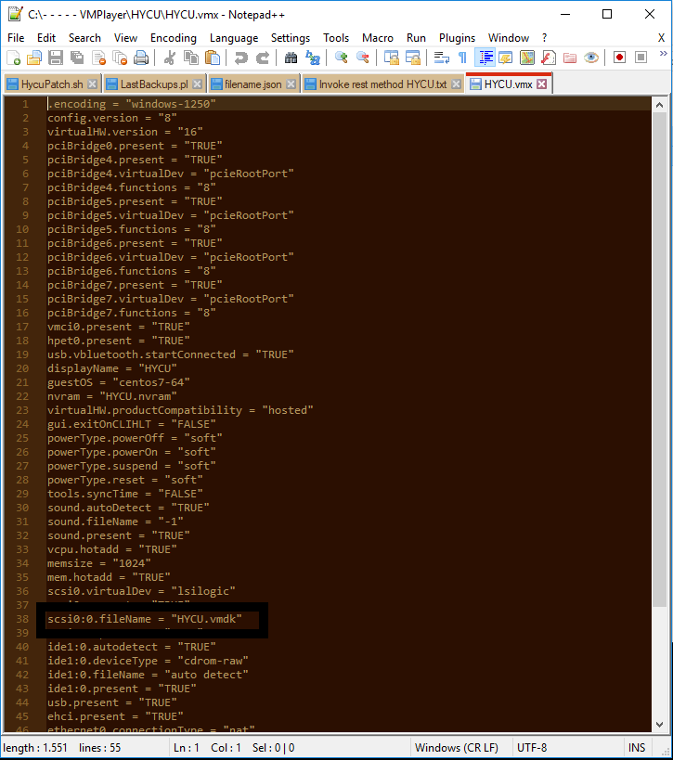
- Save the File

- Open VM player, select the VM and Select "Edit virtual machine settings"
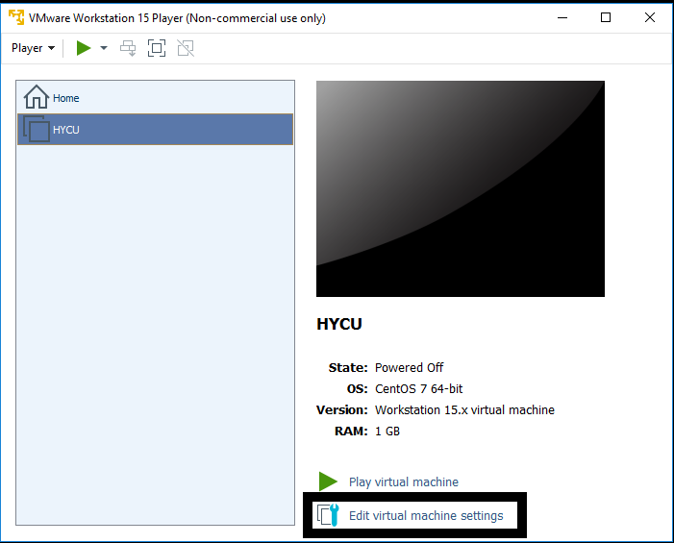
- Edit memory settings to 4 GB
- Edit Processors to 2 cores
- Remove the CD drive
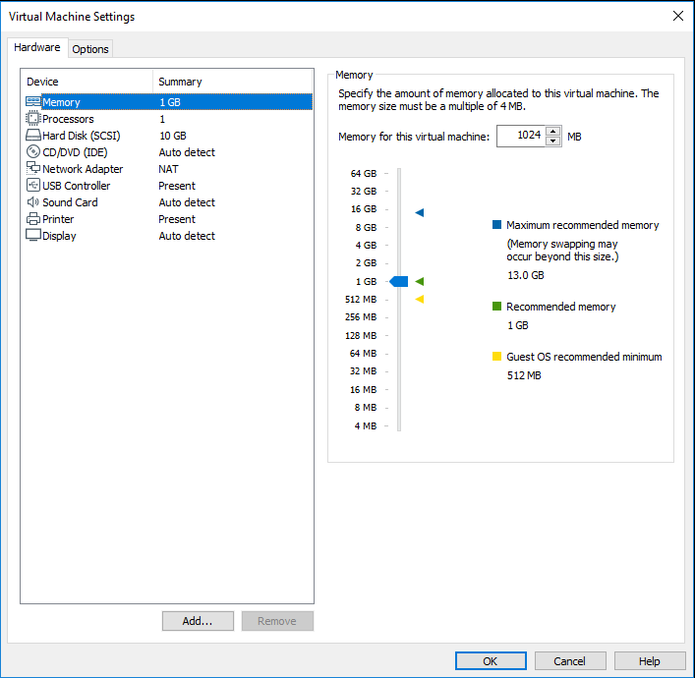

- Add another HDD, select SCSI hdd drive, "Use existing virtual disk" and browse for the HYCU data.vmdk disk image file. Click on finish and Keep existing format.
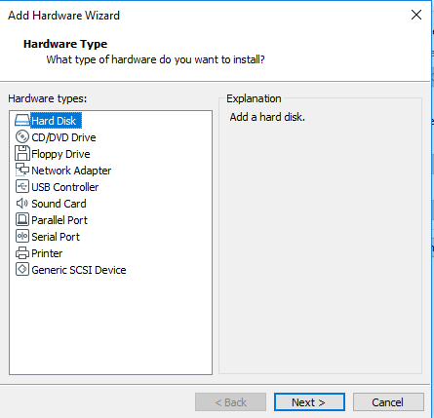
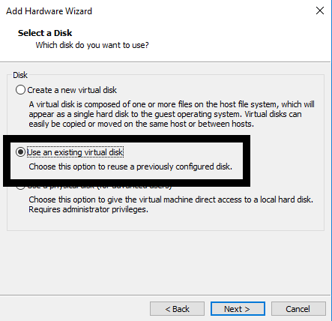
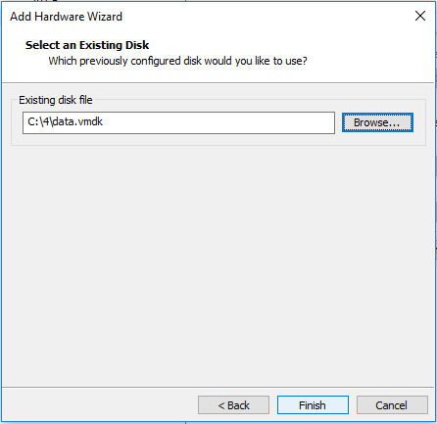
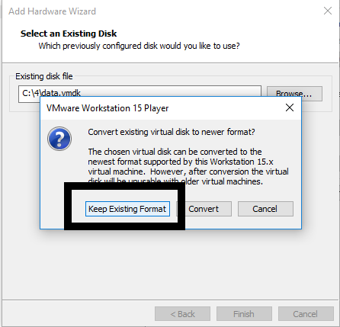

- On the network adapter select Nat
- Save the VM settings
- Run the VM
- When controller is up, login with your SSH credentials (by default this is hycu | hycu/4u). Use the command sudo nmtui to access network settings of the controller, you will be asked to enter the password one more time
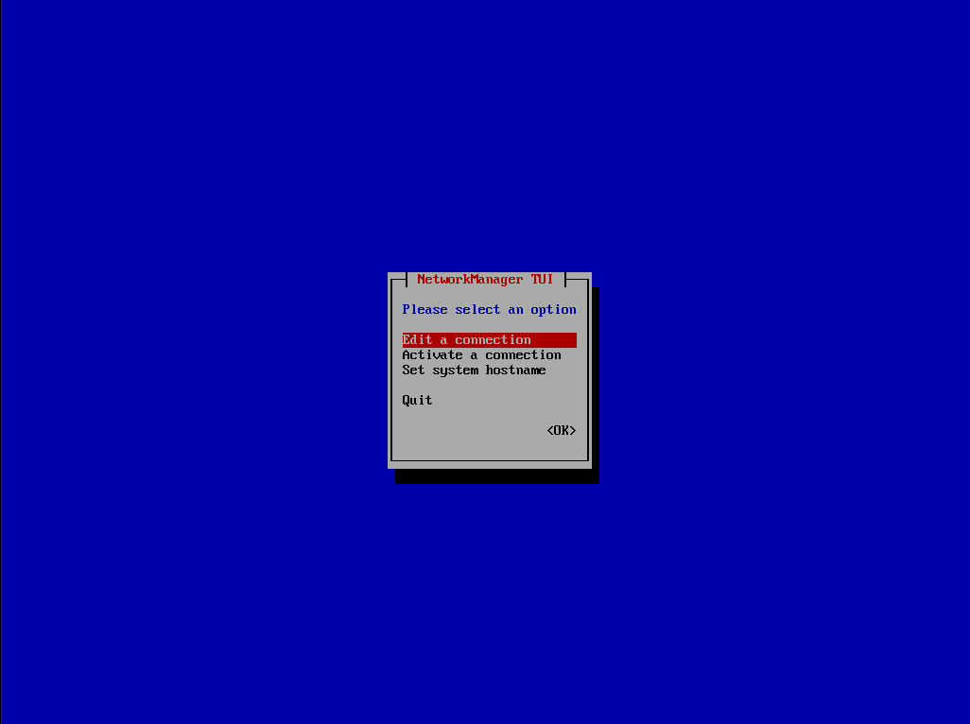
- Select Edit a connection
- Select Wired connection 1 and delete it
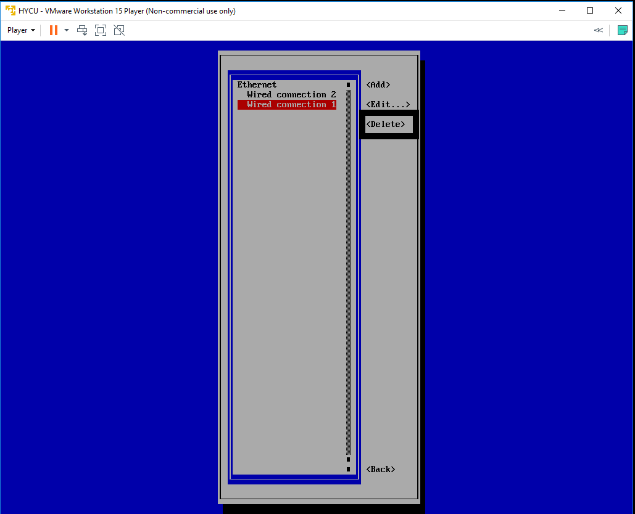
- Select Wired connection 2 and Edit it, change name to Wired connection 1
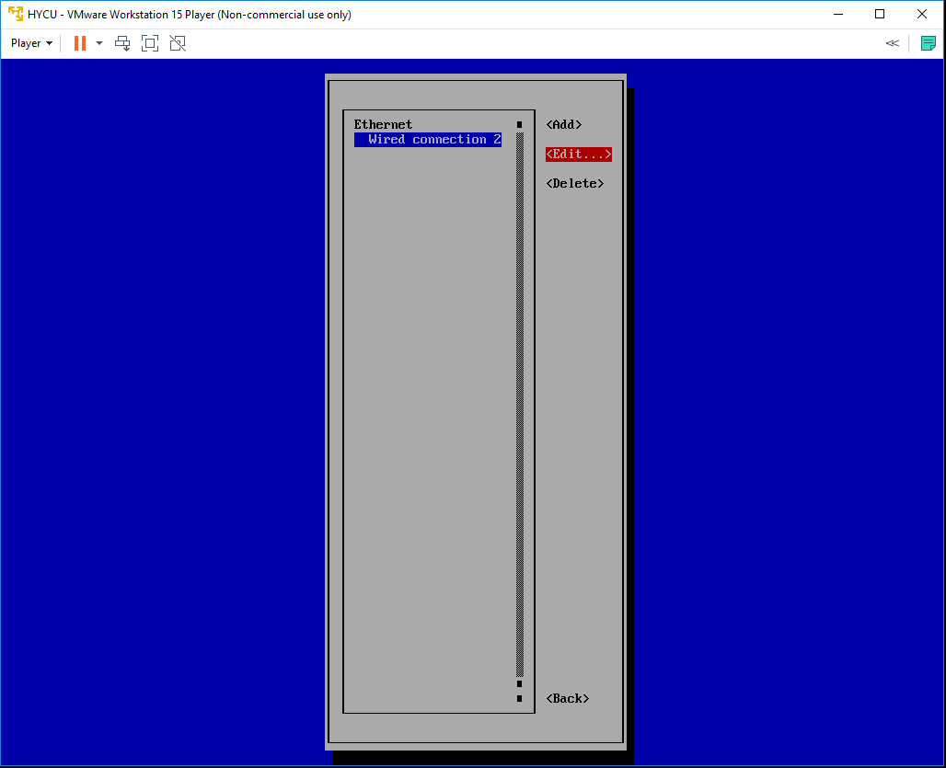
- Quit nmtui and reboot the HYCU controller VM by running sudo shutdown –r now
- SSH to the console with the same credentials and run ifconfig command to get controllers IP address
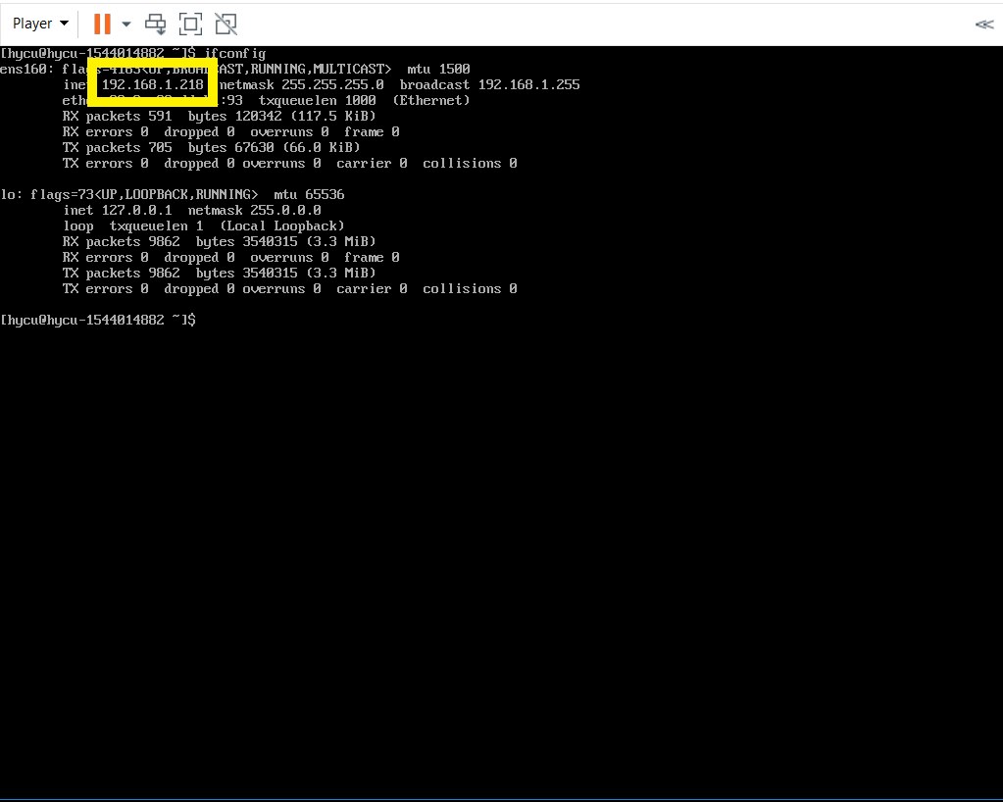
- Use that address to access HYCU GUI - https://IPaddress:8443

STEP 2 - Use HYCU to recover production virtual machines disk image files
  - video file
- Navigate to the HYCU Virtual Machines panel
- Protected VMs will be shown as PROTECTED_DELETED since source cluster is no longer available
- Select the desired VMs restore point and use “Restore VM or vDisks” option
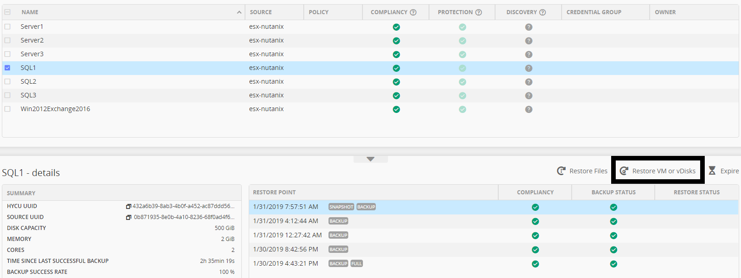
- New form will be shown. You can safely disregard the warning.
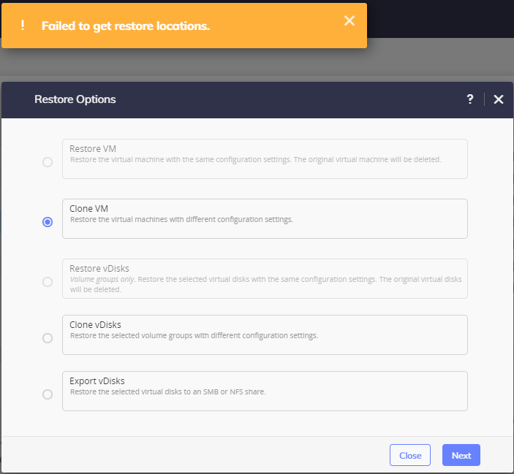
- Select “Export vDisks”
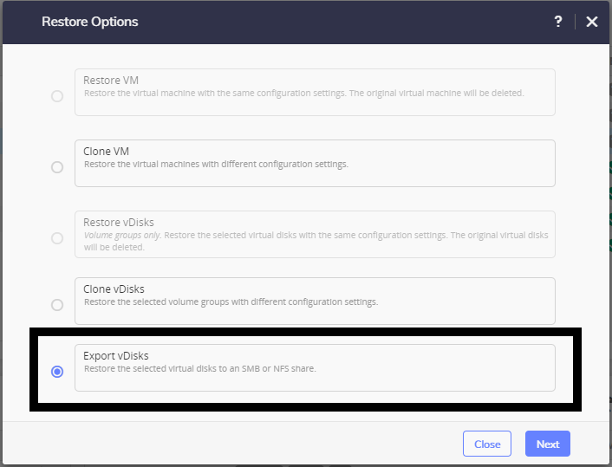

- Select vDisk(s) you want to export
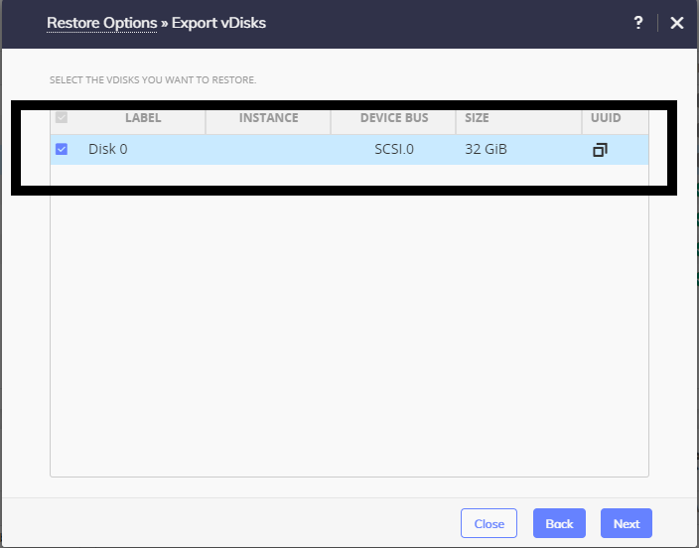
- Enter share Data
For SMB
- Domain, Username and Password are optional if exists
- Enter SMB server DNS name or IP address
- Enter Shared Folder name in format /<FolderName>
For NFS
- Enter NFS server DNS name or IP address
- Enter Shared Folder name in format /<FolderName>

- Restore Instance should be BACKUP
- Select Restore
- Once restore job is completed, you should have disk image files in specified folder. If you exported multiple disk you will have multiple raw (if exporting Nutanix ESX or AHV VM) or vmdk (if exporting non Nutanix VM) files in folder.
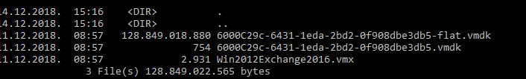

STEP 3 – Convert WMX to OVA and OVF
  - video file
- Convert *.vmx file to *.ova, for that operation you will need VMWare OVFTool available on https://my.vmware.com/web/vmware/details?productId=614&downloadGroup=OVFTOOL420
- Upon install add path of installation to environmental paths
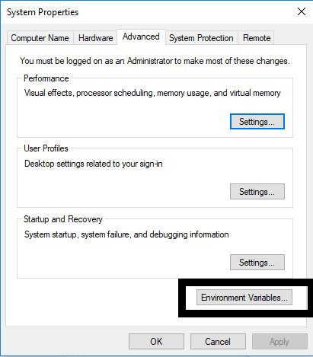
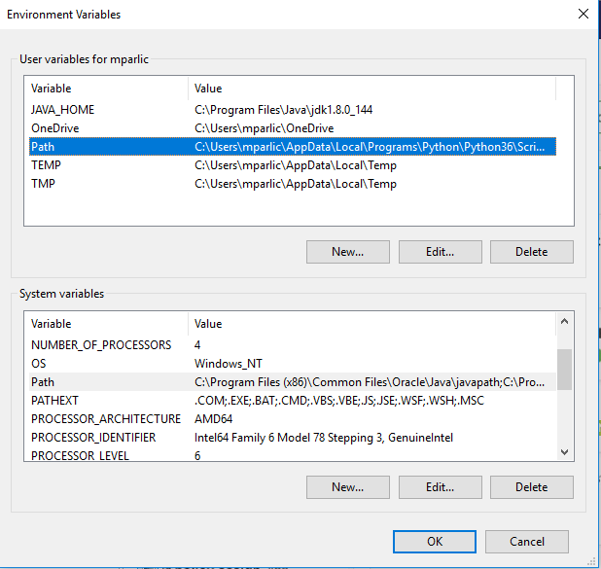
- Open Command prompt and navigate to share folder
- Use command ovftool nameOfFile.wmx nameOfFile.ova
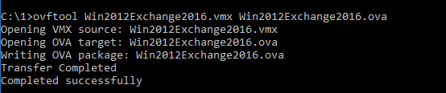

STEP 4 – Upload VM to bucket
  - video file
- Upload all files to bucket on S3 using S3 Browser available on https://s3browser.com/?v=6-5-9&fam=x64
- Add your account
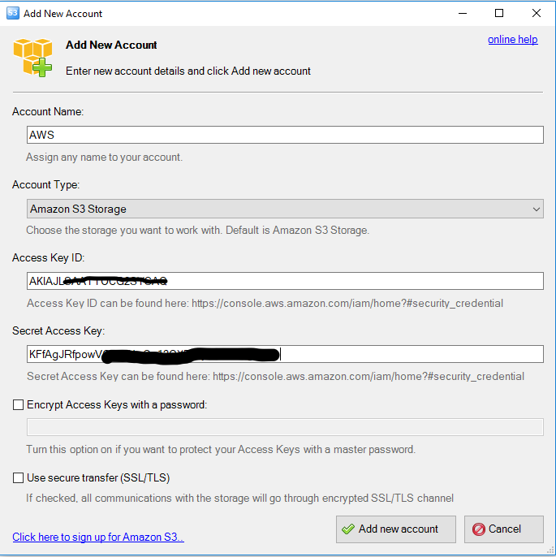
- Create new bucket
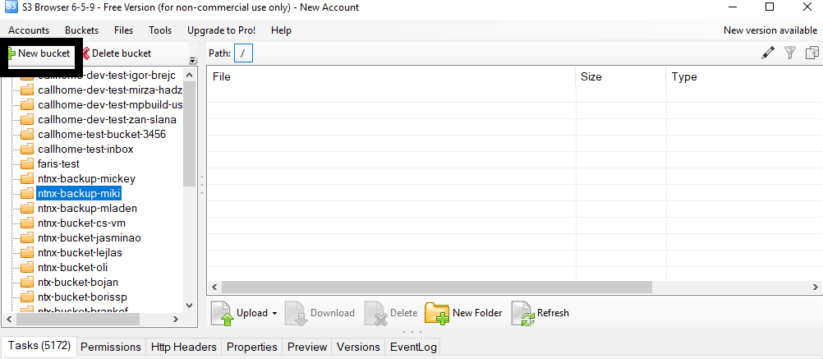
- Upload all *.ova files and *.vmdk files
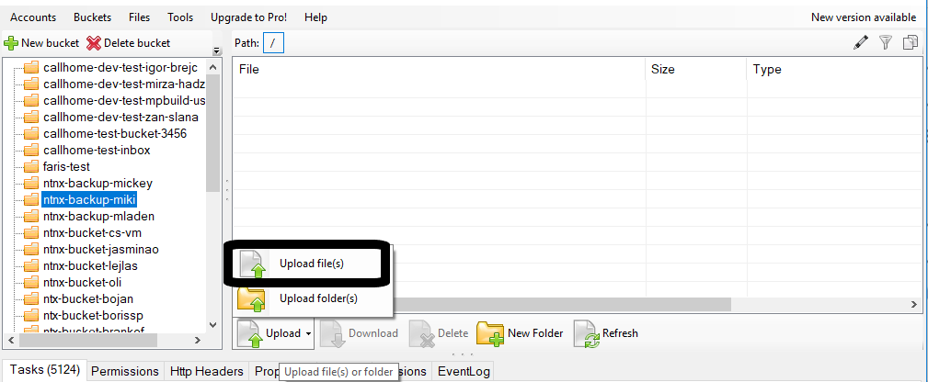
- Download AWS CLI from address https://aws.amazon.com/cli/ (download installer for Windows)
- Install AWS CLI
- Open Windows Powershell (run as administrator)

STEP 5 – AWS Configure
  - video file
- Enter command aws configure
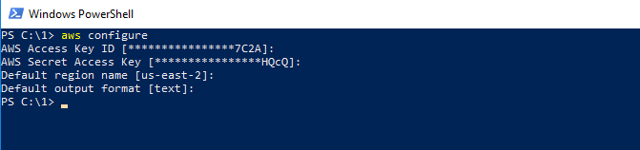
- Enter Access Key ID, AWS Secret Key, Default Region, and output type (text/json)

STEP 6 – Create and import vmimport policy
  - video file
- For next operation it is highly recommendable to have Admin permission on your AWS user, if not user need to have all permissions on EC2 and S3, and in the IAM part need to have iam:PutRolePolicy and iam:CreateRole.
- Create Folder on your local disk and navigate to the folder
- In that folder create trust-policy.json file, file should look like this
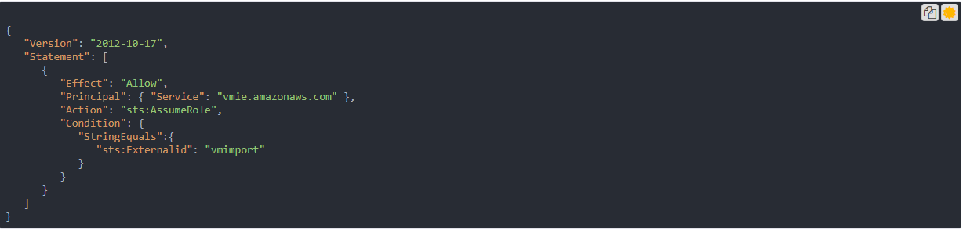
- Enter command aws iam create-role --role-name vmimport --assume-role-policy-document file://trust-policy.json

STEP 7 – Create and assign role policy
  - video file
- Create another file named role-policy.json where you need to replace disk-image-file-bucket with bucket name where you uploaded your disk images.
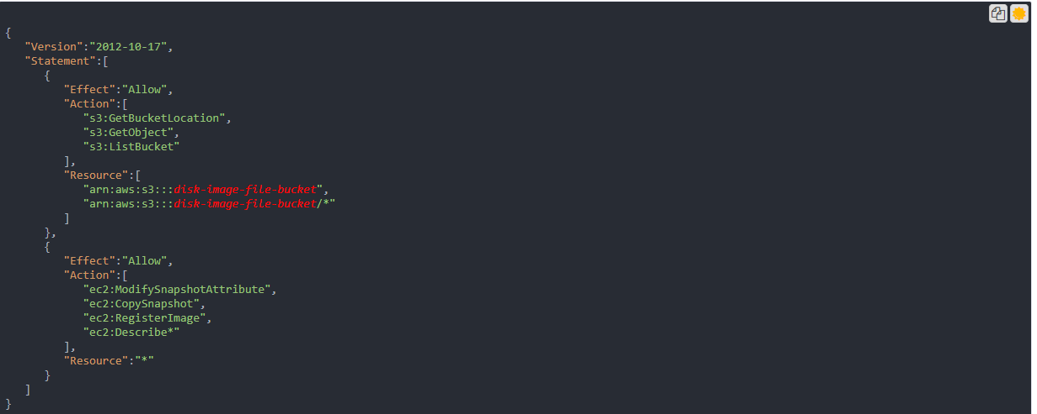
- Execute command aws iam put-role-policy --role-name vmimport --policy-name vmimport --policy-document file://role-policy.json
- Create containers.json file replace Description with your description, my-import-bucket with name of the bucket where you uploaded your files, na S3Key with name of your OVA File.
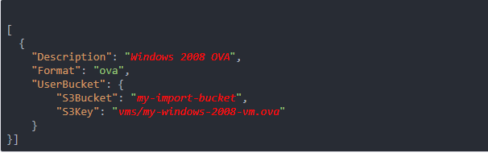

STEP 8 – Create containers.json and import VM
  - video file
- Execute command aws ec2 import-image --description "Windows 2008 OVA" --license-type <value> --disk-containers file://containers.json
- Import process will start
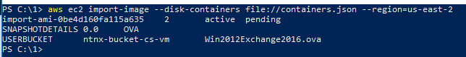
- You can check progress with command aws ec2 describe-import-image-tasks --import-task-ids import-ami-abcd1234 replace abcd1234 with number after import-ami-
- After successful import find VM in EC2 navigate to
https://us-east-2.console.aws.amazon.com/console/home?nc2=h_ct&region=us-east-2&src=header-signin#
- Select EC2
- Press button Launch Instance
- Select My Amis, and from that list run your VM that you imported

